Interfaccia Fraido

Bella Matti
Grazie !

Mi piacerebbe che il sito non si complichi più di questo : https://tomthias.github.io/fraido-website/
che si componga scendendo va più che bene

Descrivendo dall’alto in basso:
PAR 1

- Come prima immagine vorrei lo stiled della prima slide del deck contenente il logo e la frase il blu. la trovi qui allegata ma puoi trovare il PTT nella cartella 03-deck.



Primi pulsanti
Sempre tenendo come riferimento il primo sito, la prima riga di pulsanti sotto l’immagine ad oggi Our Idea e resources mi piacerebbe fosse the challenge Our Idea.

Prima riga link
Mentre la seconda riga ad oggi:
Challenge Idea Team Advisors Resources Contacts :
Mi piacerebbe diventasse
Challenge _ Main problem _ Idea _Team _ Advisors _ Resources
così che non ci siano due pulsanti nominati diversamente che fanno la stessa cosa.
Challenge: Difficult Intubation (freccia - 2punti, quello che credi)
Intubation is a medical procedure in which a tube is inserted through the mouth or nose into the trachea to maintain an open airway.
It is a critical intervention used to support breathing, deliver oxygen, and administer medication.
This life-saving technique is performed in hospital and in an extrahospital environment in civil and military settings on critically ill patients who are unable to breathe adequately on their own.
Intubation becomes difficult due to:
- stenosis
- anatomical abnormalities,
- a foreign body
or in an emergency.
Main problems:
NO space - no time - no oxygen
The key determinants of outcome are: the number of attempts
time to effective ventilation.

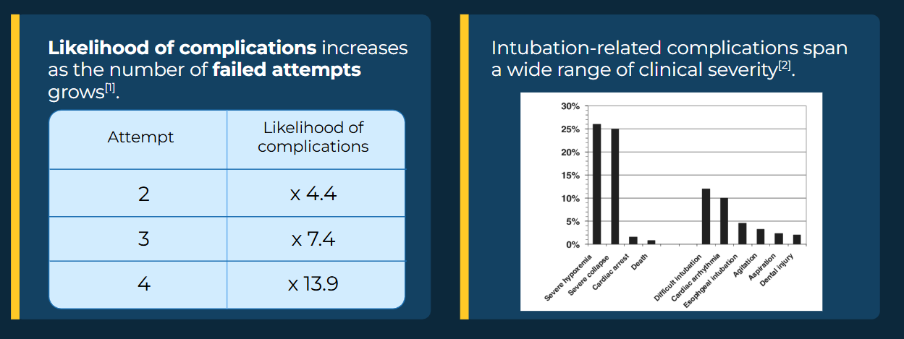
State of the art:
A combination of Fixed diameter devices is often used to reach an anatomical spot.
Like a guidewire and a tube.

A 2 step 2 device procedure.
Our Idea
One step, One device, for all the anatomy.
“Se per favore metti la gif, che trovi allegata nella cartella 02-immagini_video. con al fianco la descrizione: “

Fraido turn intubation into a a single step single device procedure:
inserting the device thin and dilate it once in place, adapting it to the patient anatomy.
A full mechanical hardware with continuous diameter control.

Team
Antonio Maria Vizioli Elia Fregonese
FOTO Foto

CEO CTO
Nurse Mat & Nanotech Engineer 5Y Emergency department 4y Space sector
Advisors (Disponili come ti pare)

Chiara Sansovini Professor Giacomo Bellani FOTO Foto

Anesthetist Anesthetist
Co Author of stargate Professor of anesthesia and ICU chief

Marco Garroni Roberto Righetti FOTO Foto

Anesthetist Anesthetist
Difficult airways instructor Difficult airways instructor

Stefano Bonvini Martin Gossling FOTO Foto

Vascular Surgeon Product designer CHief of vascular surgery Trento italy Head of commercial innovation at - UHS,Southampton

Andrew Markle
FOTO
Anesthetist
Quality management specialist
Saint Mary hospital
Resources (In deck)
Short deck Detailed Deck

Contacts ; Info@fraido.it

